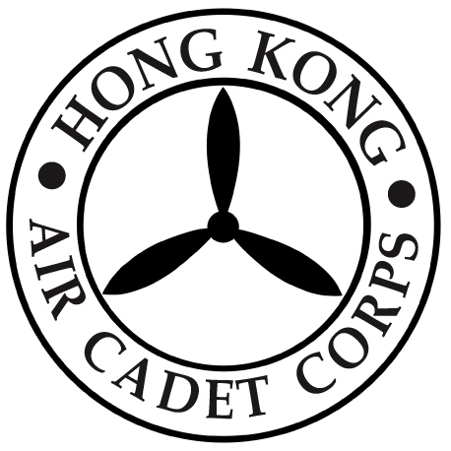
Hong Kong Air Cadet Corps

Proxy Form for the Annual General Meeting Scheduled
for Wednesday, 20 February 2019

To: Administrative Manager
Headquarters
Hong Kong Air Cadet Corps
Sung Wong Toi Road,
Kowloon.

To Honorary Secretary,

I, _____________(Name in Block Letter) of (Unit) ,
being a Voting Member of the Corps, hereby appoint
(Name in Block Letter) of (Unit), as my proxy to vote for me on my behalf at the Annual General Meeting of the Corps to be held on the 20th day of February 2019, and at any adjournment thereof.

Signed this day of 2019

Signature of the Member

Important Note: Please return the ORIGINAL of this proxy form (with signature) by post or in person to HQ, HKACC on or before 1900 hrs, 18 February 2019 (Monday) per the Articles of Association of the Hong Kong Air Cadet Corps (Companies Ordinance Cap.32).

